**Stevens Institute of Technology**

April, 2013

Water Transport in the Brazilian Amazon basin: Assessment of design and regulation of passenger vessels

**Ramon dos Santos Antunes**

**ramonsantunes@poli.ufrj.br**

Table of contents

Introduction...........................................................................................................................................3

Transportation market features………………………………………………………………………………………………………..3

Characteristics of channels………………………………………………………………………………………………………………..6

Characteristics of terminals……………………………………………………………………………………………………………….6

Vessel characteristics………………………..……………………………………………………………………………………………….8

Accidents……………………………………………………………………………………………………………………………………………9

Existing regulations……………………………………………………………………………………………………………………………11

Findings and conclusions…………………………………………………………………………………………………………………..12

References…………………………………………………………………………………………………………………………………………14

Abstract

*This report is an overview of the current situation of ferry transport in the Amazon basin. It summarizes the technical aspects of vessels and terminals deployed for passenger transportation and describes the market features in the region, in addition to an exposition of the existing regulations and future plans regarding the inland navigation at the Amazon basin. This study is limited to ferry transport at the main channels, which connect the main cities. This work is to propose new measures and modifications regarding the universe of ferry transport in Amazon aiming the improvement of safety levels, and its conclusions can be found at the end of the report.*

Introduction.

Currently inland navigation in the Amazon basin is the most critical sector of the transportation system in Brazil, and it needs to be better regulated, especially in terms of economics. Due to the precarious rail and road networks, the alternatives for transportation (both cargo and passenger) in this region is restricted to the water and airways. The latter is not compatible with the average income of that region, which makes the waterborne transportation the most used alternative for moving both cargo and passengers.

There are federal regulations (NORMAM-02) addressing the permitting and crewing of the vessels, as well as some minimum standards for safety, sanitation and comfort of the passenger², but they are not very effective due to the difficulty of inspection, related the large number of vessels (more than 150,000¹ units deployed in commercial activities) in the major and minor channels – including small canoes used commercially as well, the large geographic dispersion, and the lack of both tools and interest by the small cities which they serve.

In general, the vessels are used for a mixture of general cargo and passengers but are not designed to this purpose, leading to inefficient ships (high fuel consumption and low speed) ³.In addition the market features in this region lead to serious problems that could be solved with economic regulation.

Transportation market features

Annually about 12 million passengers move by the Amazon Rivers (main and minor channels), and more than 50 million tons were moved through the waterways last year7. The passenger transportation market in the main waterways presents currently 41 private companies managing 64 vessels8, distributed in 6 routes as we can see on the following table1:

**Table 1: Age, Hull material and Passenger Capacity of Ferries on the main Amazon Lines**

|  |  |  |  |  |  |  |  |
| --- | --- | --- | --- | --- | --- | --- | --- |
| **Line** | **Average fleet age (years)** | **Hull material** | | | | **Vessel capacity\*** | |
| **Steel** | **Lumber** | **Aluminum** | **Total** | **Average** | **Total** |
| Manaus- Santarém | 11.6 | 10 | 5 | 1 | 16 | 176 | 2,812 |
| Manaus-Belém | 19.9 | 3 | 6 | 0 | 9 | 221 | 1,993 |
| Belém-Santarém | 42 | 2 | 1 | 0 | 3 | 265 | 795 |
| Belém-Macapá | 12.8 | 5 | 4 | 1 | 10 | 201 | 2,103 |
| Santarém-Macapá | 17.1 | 8 | 0 | 0 | 8 | 125 | 1,001 |
| Manaus-Porto Velho | 6.4 | 14 | 0 | 0 | 14 | 178 | 2,493 |
| **Total** | **14.3** | **42** | **16** | **2** | **60** | **185** | **11,107** |

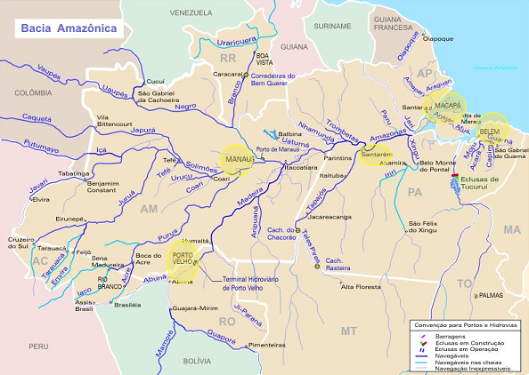

**Figure 1: Cities connected by the main waterway lines**

The market features in this region (low-income users, inefficient vessels, nonexistent economic regulations, surplus of supply and deficiency of information) lead to some consequences:

* Low service quality level;
* Predatory competition;
* Low occupancy rate;
* Low investments;
* Low profitability;
* Excessive downtimes;

The voyage times are generally elevated due to two main reasons: the vessel speed and the long laytime of vessels due to the mixture of cargo and the inappropriate terminals. Table 21 shows the mean travelling time for the main channels.

|  |  |  |  |
| --- | --- | --- | --- |
| **Routes** | **Distance (miles)** | **Travelling time (hours)** | **Average Speed (knots)** |
| Manaus-Santarém | 409 | 30 | 13.6 |
| Santarém-Manaus | 48 | 8.5 |
| Belém-Manaus | 889 | 120 | 7.4 |
| Manaus-Belém | 96 | 9.3 |
| Belém-Santarém | 475 | 60 | 7.9 |
| Santarém-Belém | 48 | 9.9 |
| Belém-Macapá | 310 | 22 | 14.1 |
| Macapá-Belém | 22 | 14.1 |
| Manaus-Porto Velho | 728 | 96 | 7.6 |
| Porto Velho-Manaus | 72 | 10.1 |
| Santarém-Macapá | 303 | 35 | 8.7 |
| Macapá-Santarém | 40 | 7.6 |

**Table 2: Routes, distance, travelling time and average speed of ferries on the main Channels**

*The travelling time is different depending on the direction for the same route due to the river current speed.*

Certainly some economic regulations would also help to improve the safety of vessels operations and the quality of the ships, once the predatory competition would end and the profit margins would increase – as well as the service quality level. In this context, regulations would include licensing, establishment of maximum and/or minimum prices, competition rules and limited number of permits to operate.

Although the occupancy rate is generally low, in the peak months there is overcrowding of some vessels. Overcrowding is one of the main causes of capsizing accidents (in addition to compromising comfort and health of the passengers and crew).

Characteristics of channels

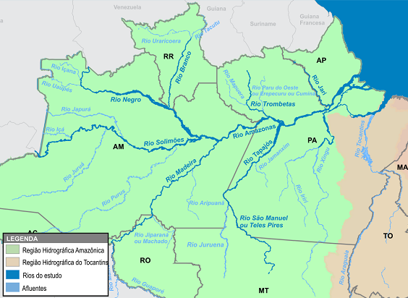**Figure 2: main rivers in the Amazon basin**

|  |  |  |  |  |  |  |  |  |  |
| --- | --- | --- | --- | --- | --- | --- | --- | --- | --- |
| River | Amazon | Negro | Branco | Madeira | Solimoes | Trombetas | Jari | Tapajós | Teles Pires |
| Length (km) | 1508 | 1200 | 600 | 1425 | 1620 | 800 | 780 | 851 | 725 |

**Table 3: Length of main river channels**

The average widths of the rivers are impressive: 1000 m (Madeira), 1210 (Solimoes) and 2000 (Amazon) 10. According to the ministry of transportation, there are no navigational constraints at these main channels – which allows for any kind and size of vessel. The terminals do present constraints – which certainly drive the type of vessels navigating these waterways.

Characteristics of terminals

The majority of terminals are not designed nor are suitable for the loading/discharge operations and the access to the vessels is the same for both cargo and passengers, as demonstrated by the following pictures. The biggest terminals do have proper facilities for each and are reasonable, from a technical perspective (duly designed and dimensioned for their purpose).

***Figure 2: Terminals in the Amazon basin.4*** *2a - Terminal of Cai N’agua, city of Porto Velho – Rondonia. 2b - Terminal of Santarém, Para. 2c - Passenger terminal Roadway, city of Manaus, Amazonas*

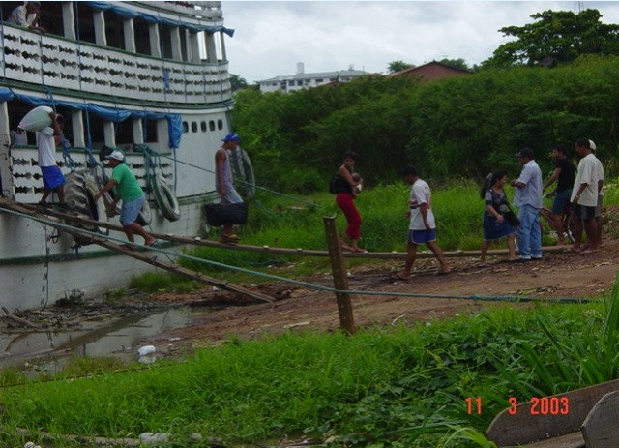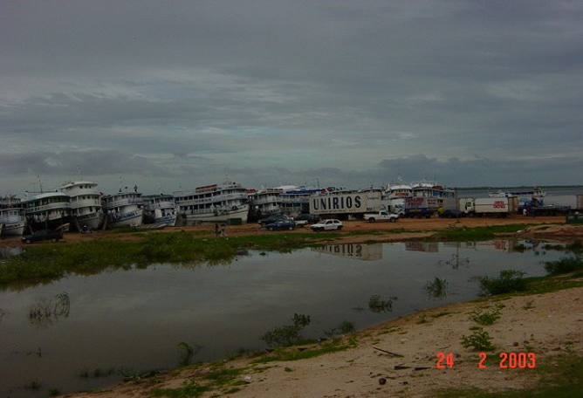

*Figure 2a* *Figure 2b*

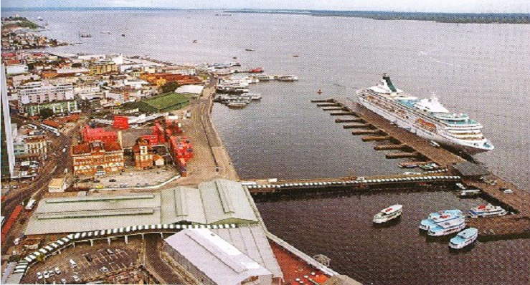

*Figure 2c.*

One interesting alternative that has proved to be effective and suitable for the Amazon region, where the water level can vary 15 meters between the low and high tides, are the floating quays11 – allowing, thus, the continuous operation of the terminal, receiving bigger and heavier vessels – as the used in the Town of Novo Airão (Figure 4).

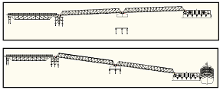**Figure 3: Floating quays scheme at the high and low tides.**

**Figure 4: Floating Quay of Novo Airão, Amazonas**

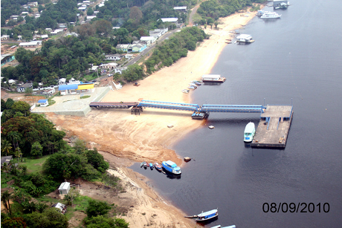

Characteristics of vessels

There is a paucity of information on the technical aspects of such vessels in the literature, but some aspects are listed below1, 3,6:

* 70% steel hulls (considering only the main routes; considering the entire basin there are more wooden hulls);
* Most of them are constructed upon craft techniques and by small shipyards;
* Existing adaptations are generally reckless and inefficient – for instance, the substitution of the existing engine for a bigger one, without any assessment or consideration of impact;
* Their propellers are generally the same for all vessels (in type and size, contributing for the overall inefficiency of the vessel);
* The vessel beams (width) are predominantly in between 7.0 – 8.6 meters;
* An average of 185 passengers per voyage;
* The average age for the vessels is 14.6 years. More than 50% are younger than 10 years (due to the entry of new traders);
* Dominant cargo type is grocery;
* The average capacity needed for cargo is 147 metric tons;
* Average speed of 9.9 knots (including the current velocity and laytime).

**Figure 5: Amazon regional vessels1**

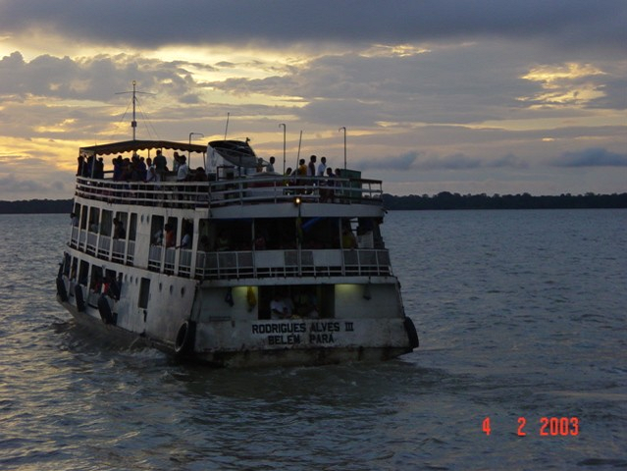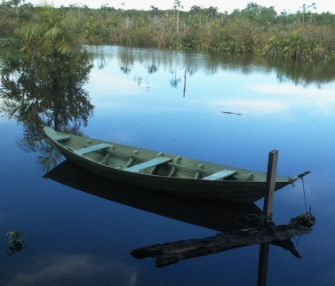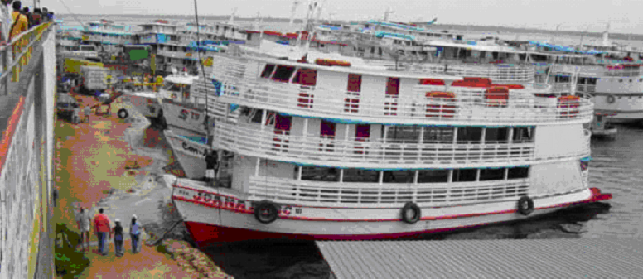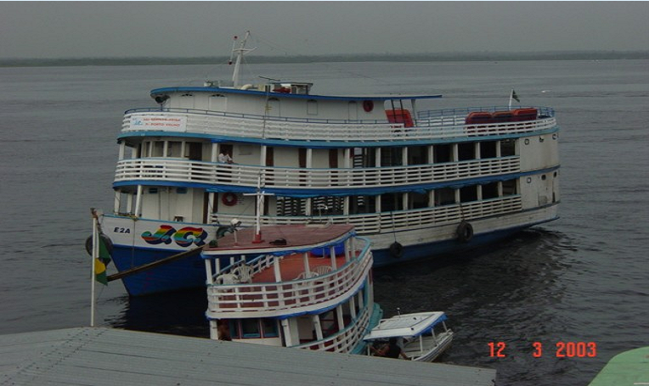

*The bigger ones are deployed on the main lines, while canoes are more common in the smaller cities and channels*

Accidents

As majority of vessels at the Amazon basin are wooden hulls, we should expect that the most of accidents occurred with these, because longitudinal timbers are used to construct these hulls, which means that a collision at a well defined region of the ship can lead to a crack all over the hull. This event is much harder to happen with steel vessels, due to their flexibility and ductility. However, what Table 4 and Figure 6 show is that 54% of the reported casualties occurred with steel hulls13. A coherent explanation for that is most of the steel hull vessels have insurance, and, in case of accident, the report of the occurred is required to make the claim – which does not happen with the majority of wooden hull vessels.

The lack of more technologically developed techniques contributes to the heterogeneity of vessels with similar functions and the difficulty of quality standards for compliance and inspection – ultimately compromising the safety at certain level. Errors regarding basic design components directly influence the vessel effectiveness (generating vibration, noise, heat, fuel inefficiency, low speeds).

**Figure 6: percentage of reported accidents related to hull material** **Table 4: number of reported accidents related to hull material per year**

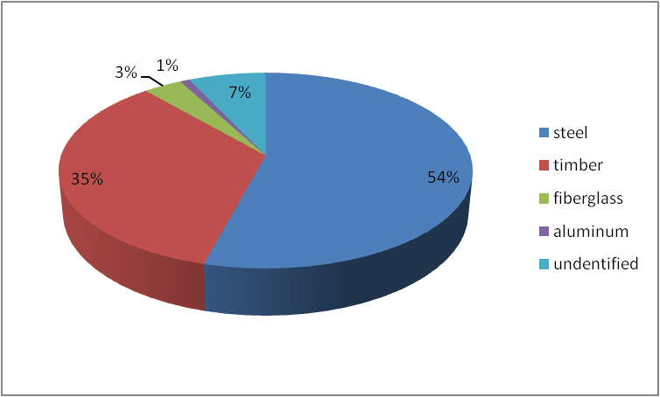

Unfortunately more detailed information on the type of cargo and the navigation course were not found. Such information would be helpful for a reasonable vessel design, since certain types of cargo demand special storage and handling (for this work it would be helpful to know the different types of grocery carried), and the navigation course could imply in the operational strategy of the ship (fuel tanks size, for instance).

Regarding the causes of accidents the following chart indicates that human errors (negligence, imprudence or/and malpractice) are the major responsible, followed by vessel failure (flaw of technical components) 13.

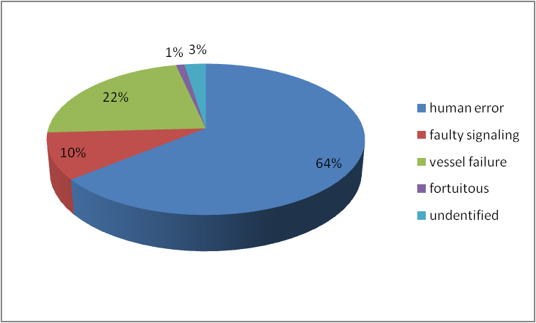 **Figure 7: percentage of accident related to its cause Table 5: cause of accident per year**

If we analyze closer the existing studies about ferry accidents in Amazon, it is possible to break the causes above into directly related issues:

* Precariousness of deployed vessels (in the sense of poor hull material – lumber, aged machinery and propulsion systems and mixture of cargo and passenger in the same hold);
* Poor quality operations (lack of crew training);
* Lack of maintenance;
* Inappropriate design;
* Overcrowding;
* Non-standardized craft construction techniques;
* Absence of partitioning - the whole ship doesn’t comply with the requirements for compartmentalization;
* Imprudent elevation of the center of gravity (construction of third deck to accommodate more passengers or cargo).

Some numbers as the shown below illustrate the existing scenario at the region. Although the lack of information, it is possible to affirm that one really recurrent accident is scalping (most related to canoes, used to transport up to 6 people), due to the reckless installation of any type of engine to the boat, leaving the high speed shaft without any protection.Scalping here means the violent removal of the scalp due to the winding of the hair around the high speed shaft.

Existing Regulations

Currently two agencies are responsible for regulating the navigation in Brazil: the National Agency of Waterway Transportation (ANTAQ) and Marinha do Brasil. The latter can be roughly compared to the navy and coast guard, in the sense that they have the same responsibilities, and is the federal maritime authority. The current regulations regarding the inland navigational vessels are found at the NORMAM-02*(Norms of the maritime authority for inland navigation vessels), which sets minimum standards of safety, crewing (just a minimum number, not training or quality standards), habitability and cargo/passenger space – besides some technical specifications standards (stability criteria, signaling, surveillance procedures, among others). These regulations are based on the IMO suggestions, adapted for inland navigation.

With the creation of the ANTAQ, in 2002, much improvement on data, studies, efforts, investments and ultimately in the safety of transportation at the Amazon basin occurred. The numbers of vessels surveyed demonstrate the influence of this regulatory body through the years, especially between 2002- 03 (Table 6):

**Table 6: Number of Amazon Basin vessels surveyed annually5**

|  |  |  |  |  |  |  |  |  |  |
| --- | --- | --- | --- | --- | --- | --- | --- | --- | --- |
| **Year** | **2000** | **2001** | **2002** | **2003** | **2004** | **2005** | **2006** | **2007** | **2008** |
| **Quantity** | 14,756 | 16,861 | 21,232 | 31,920 | 36,226 | 41,208 | 44,768 | 43,788 | 46,171 |

The number of surveyed vessels increased significantly since 2002 when ANTAQ was created.

In fact a well detailed federal regulation for inland navigation exists, but several aspects are considered lax by the SOBENA (Brazilian Society of Naval Engineers), for instance: non-restriction of use of lumber for construction of over-100-passenger new hulls, non-obligation of certification for over-100 passenger vessels, requirement for firefighting system only for vessels over 300 GT (gross tonnage), etc. So, from a technical perspective, there are reasonable regulations despite the critics, but only for bigger vessels. Considering that most of the accidents are related to smaller vessels (a large quantity of them canoes, adapted with reckless propulsion systems), some effort aiming regulations for this class should be undertaken.

Unfortunately, no economic standard or regulation exists for the transportation market in this region. This is considered the root cause for majority of the issues cited earlier¹, since it drives the low profit margin in this market, preventing investments on improvement of the vessels (ultimately the safety).

Efforts from the ministry of transportation seek to improve and make crew training mandatory, but currently these requirements are not in force. Also studies about the transportation market and the ferries deployed in the Amazon region are been developed by federal universities in Brazil (UFPA – federal university of Pará and UFRJ – Federal university of Rio de Janeiro) to collect data for further researches and projects.

Findings and conclusions

In order to improve the entire transportation system at the Amazon basin, a joint effort among the ANTAQ, the “Marinha do Brasil”, regional regulatory agencies and the federal government is necessary. Actions regarding economic regulations, effective regular inspections, improvement of terminals and crew preparation (training) are the key targets that need to be better analyzed to regulate the passenger transportation in this region.

Accurate and detailed data acquisition on vessel accidents is of great importance for further research and analysis, so it should be implemented as soon as possible by the cognizant agency – in the author’s opinion, the ANTAQ. Technical regulations focusing smaller vessels – as canoes – are extremely necessary, and the review of several norms at the NORMAM should be revised, as pointed out by SOBENA.

Information exchange with successful ferry transport initiatives and companies, as well as consultancy, can speed up the process of safety improvement. Also the designation of a specific agency to implement and inspect crew training would be necessary for the entire organization of this process - which is expensive, bureaucratic and time consuming.

Another factor – actually the proximate cause – that influences the accidents, sinkage, flooding and injuries is the technical and operational condition of the vessels (usage status of the engine, shaft, auxiliary systems and general equipment). Assuming a scenario where the market is regulated (perfect competition) and the inspection of vessels and enforcement are duly implemented, we could analyze the safety of these vessels mostly from a technical perspective. In this case, some modifications could be very effective, as the listed below:

**Table 7: Technical modifications proposed for Amazon ferries safety improvement**

|  |  |
| --- | --- |
| Modification | Rationale |
| Wooden hulls for Steel/composite hulls | Steel, as well as composite materials, is more flexible and ductile (better structural integrity than wooden hulls) |
| Single screw for Twin screw | Twin screw vessels present two propellers, what provides redundancy in the case of flaw of one of the screws. |
| Proper compartmentalization | Compartmentalizing the vessel is essential for the survivability of the vessel in case of flooding, avoiding “progressive flooding” |
| Particular design features (engine, propellers, shaft, etc.) | Proper designed components are responsible for an efficient and noise-free vessel |
| Outboard motor for canoes and small boats | This prevents the high speed rotating shaft to cause any accident (scalping, most of the times) |
| Deployment of catamaran hulls | Catamarans are harder to capsize – a big concern for overcrowded vessels |
| Higher guardrails | Prevents falling from the vessel |

The safety of ferries can be improved. It demands time, money, research and commitment – the latter from everyone involved, mainly the customers. In the short term they can be the supervisors, demanding the accomplishment of the existing regulations for their own safety. However, they have to know what to require, and this can be done by an awareness campaign. Although such campaign may provide a short term solution, the regulation of the market environment is certainly the principal measure to improve the ferry transport in Amazon. It would attract potential investors, due to the possibility of good profit margin (despite of low income, the number of users is impressive), who consequently would invest in vessel technology and safety improvement.

Acknowledgements

To my mentor Dr. Roberta Weisbrod, expert on safety of ferries and principal of Sustainable Ports, who guided me with the organization of this paper.. To Mr. Jorge Nikulin, naval architect, marine engineer and technical consultant at PETROBRAS, who provided me guidance with accessing information I needed to this work.

References

¹ - *“Inland waterway passenger transportation regulations: the Amazon case”, Floriano C. M. Pires Jr, Luiz Felipe Assis, Cassiano Marins Souza, 22*nd Waterway transportation national congress, 2008. (<http://sobena.org.br/publicacoes.asp>)

²- “*Norms from the maritime authority for vessels deployed in inland navigations* *– NORMAN 02”, Marinha do Brasil, 2005.*

*³-*“*Fluvial passenger transportation risk assessment on the Amazon region*”, Carlos Daher Padovezi, 24th Waterway transportation national congress, 2012. (<http://sobena.org.br/publicacoes.asp>)

4-“*The regular and tourist waterway passenger transportation*”, Alves , Luiz Eduardo da Silva. 2007.

5- Charter Sta3, Center for social communications of Marinha do Brasil.

6 - *“Fluvial Amazonic passenger transportation*”, Nobrega, Carlos Alberto Wanderley. III International Congress on Amazonic transportation, 2003

7-“ [*Tokarski destaca crescimento do transporte fluvial na Amazônia em seminário na Câmara dos Deputados*](http://www.portosenavios.com.br/site/noticias-do-dia/navegacao/21331-tokarski-destaca-crescimento-do-transporte-fluvial-na-amazonia-em-seminario-na-camara-dos-deputados)*”* Portos e Navios magazine, Noticiário Cotidiano, March 28 of 2013. (<http://www.portosenavios.com.br/site/noticias-do-dia/navegacao/21331-tokarski-destaca-crescimento-do-transporte-fluvial-na-amazonia-em-seminario-na-camara-dos-deputados>)

8-“*Inland Waterway Passenger Transportation Regulation*”, Nobrega, Carlos Alberto Wanderley. 4th seminar on transportation and inland waterway development, 2005.

9-“*Technical report: Amazon basin*”, ANTAQ and UFSC. February 2013.

10- Ministry of transportation website. ([http://www.transportes.gov.br](http://www.transportes.gov.br/))

11-“*Alternate designs for waterway terminals in the Amazon region*”, Édison de Oliveira Júnior, Luciano Moreira de Sousa Filho, Evailton Arantes de Oliveira. 23rd Waterway transportation national congress, 2010. (<http://sobena.org.br/publicacoes.asp>)

12-“*Path and Conflict at the Paraense Amazon waterways: a study on vessels accidents*”, Maria Martins da Rocha Diniz Bastos, 2006.

13-“*Oriental Amazon vessels safety analysis”,* Ariane Cardoso de Souza, Miguel Calandrini da Silva Neto, Hito Braga de Moraes. 22nd Waterway transportation national congress, 2008. (<http://sobena.org.br/publicacoes.asp>)