Brian Cooksey
ANOTHER AVOIDABLE FERRY DISASTER on LAKE VICTORIA: AREN’T WE MISSING SOMETHING?
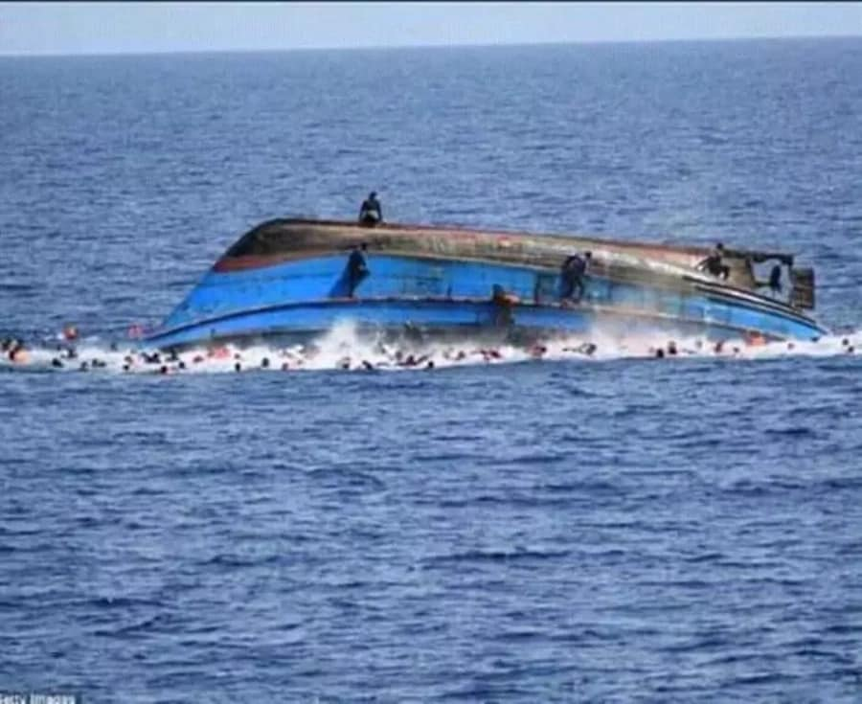

MV Nyerere seconds after capsizing. Most of those in the water survived.
Most of the 228 passengers who perished were trapped inside the hull.

SUMMARY:
- The overwhelming consensus is that the MV Nyerere capsized as a result of overloading;
- Overloading is the result of human error: those consciously and purposely overloading the ferry were responsible for its capsizing and the consequent deaths;
- Since the ferry is state owned and managed, and maintenance and enforcing safety controls are state responsibilities, those who should be held responsible for the tragedy are exclusively government officials, starting with the captain and crew, and working back along the chain of command;
- Routine overloading is the result of the shortage of ferry services to meet the demand for passenger and freight transport;
- The shortage of ferry services is the result of government policy decisions not to open up ferry services to private sector competition, which would result in private investment to meet the demand, with the replacement of mediocre and dangerous state-provided services;
- Safety regulations are flouted in the interest of overloading ferries with as many passengers as possible, most of whom are unrecorded and their fares unreported;
- The rents resulting from this process assure its continuation at the expense of transport safety and efficiency.
Sudden death on a Thursday afternoon
In the early afternoon of Thursday September 20th 2018, a crowd of people congregated at the tiny port of Ukara Island on Lake Victoria. It was market day. The crowd was waiting for the arrival of the MV Nyerere, a small ferry bringing passengers, including traders, and cargo from nearby Bugolola on Ukerewe Island. It was a sunny day, with a refreshing breeze blowing off the calm lake. As the 100-capacity ferry approached the jetty, passengers gathered on deck to wave to their relatives and prepare to disembark. Suddenly the MV Nyerere made an abrupt turn to align with the jetty. With so many passengers congregating on one side of the boat, it keeled over wildly to starboard, righted itself momentarily, and capsized on the port side, throwing dozens of passengers into the shallow water. Two hundred and twenty-eight people drowned within minutes, most of them trapped inside the upturned hull. About 40 people were rescued by small boats. The identities of some of the dead remain unknown, since the passenger manifest went down with the ship, or so we are told.

Within hours, the BBC World Service was broadcasting the shocking news worldwide. Tanzanian President John Magufuli declared four days of national mourning, and flags flew at half-mast. He said: “it appears clear that the ferry was overloaded”. “Negligence has cost us so many lives … children, mothers, students, old people.” He “ordered the arrest of all those involved in the management of the ferry. The arrests have already begun,” he added. The president said the government would cover the funeral expenses of the victims. A ‘condolence account’ was opened for the victims’ families, and cash payments were promised for bereaved families to take the corpses of their dead home for burial. Condolences came pouring in from near and far. Presidents Kagame of Rwanda and Kenyatta of Kenya sent their messages of solidarity to Tanzania’s mourning President and citizens. President Shein of Zanzibar ‘called for calm from those touched by the news, especially when mourning…’ CCM Secretary General Ally Bashiru urged people to ‘continue praying for the survivors and rescue teams and the authorities responsible for ensuring all bodies are recovered.’ A day later, President Magufuli directed the relevant authorities to announce tenders for a new ferry with a capacity of 200 passengers, twice that of MV Nyerere. He also formed a seven-member investigative team led by a former army general to ‘establish the cause of the disaster.’ Subsequently, the President dissolved the board of directors of the Tanzania Electrical, Mechanical and Electronics Services Agency (TEMESA, established 2005), who run ferry services on Tanzania mainland, as well as the board of the country's transport regulator, the Surface and Marine Transport Regulatory Authority (SUMATRA).
Thing's will soon be back to normal...
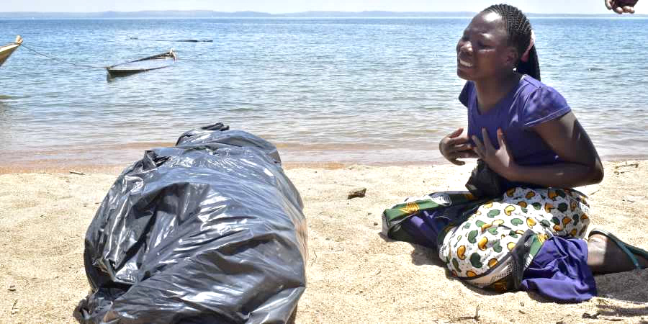
Less than two weeks earlier, on September 14th, the Member of Parliament for Ukerewe District, Joseph Mkundi (Chadema), complained in the National Assembly that he had repeatedly warned the government that the MV Nyerere was ‘malfunctioning’ and in urgent need of repair. A government spokesperson claimed that new engines had been fitted quite recently. The day after the disaster, Minister of Home Affairs Kangi Lugola ‘warned people to desist from spreading false information that might cause turmoil in the country.’ President Magufuli ‘cautioned politicians about taking advantage of the situation to gain political mileage and cheap publicity.’ Prime Minister Kassim Majaliwa said the government had started to take steps to bring the lives of the residents in the area ‘back to normal’.
Many bereaved families could not take the already decomposing bodies of the victims home for burial, so they were summarily buried near the lake shore, next to anonymous corpses claimed by no-one. Within days, the dead and bereaved were largely forgotten, and the public’s attention was turned towards the tricky task of salvaging the ferry, which was finally achieved nine days later. President Magufuli directed that each of those who participated in the ‘salvage and recovery exercise’ should be given 400,000/- (USD175) ‘for their tireless efforts…’ Mining giant Acacia, that contributed Shs 80million (USD35,000) to the disaster victims and their families, ‘was impressed by the work done by the government including the fact that “the ill-fated ferry has also been turned upright” and pulled ashore.’ Bravo.
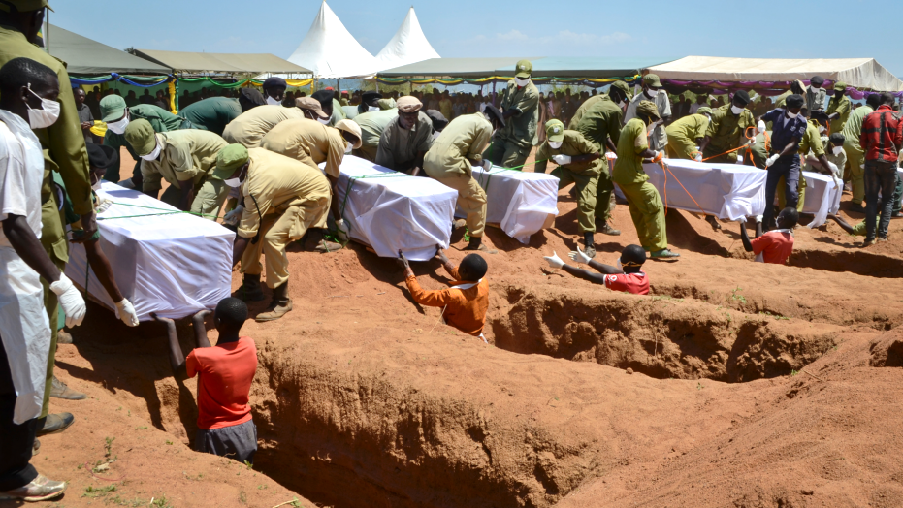
On 24th September, Prime Minister Kassim Majaliwa announced the formation of a seven-person team led by former Chief of the Defence Forces General George Waitara to investigate the causes of the disaster. Members of the team are: Ukerewe MP Joseph Mkundi, former TEMESA chief executive Marcelina Magesa, advocate Julius Kalolo, Ms Queen Mlozi, police officer Cammilus Wambura, and Bashira T Hussein from the PMO’s Department of Disaster Management. The PM gave the team a month to complete its enquiries.

Why boats sink
There are two reasons why civilian passenger and cargo ships sink and people die: natural disasters and human error. Many ships sink when they run into bad weather, high winds, and heavy seas. In other cases, human errors are the main cause. Natural disasters are much more likely to happen at sea than on lakes. Below are a few examples of maritime disasters attributed to human error rather than purely natural causes.

The sinking of the MV Spice Islander I in 2011 was the sixth largest peacetime maritime disasters ever recorded, with more deaths than the Titanic, the most famous sea disaster of all time. Thousands of deaths on small boats and canoes go unrecorded, although in total they probably outnumber the tragedies discussed here. (Artisanal fishers also die in considerable, but unknown, numbers). A thousand minor catastrophes each resulting in a few deaths are not worth one big one even if many more lives are lost in aggregate.

The human errors involved in mega-disasters include collisions, running aground, fires and explosions, and capsizing due to structural defects and overloading. Many people drown because they don’t know how to swim and there are no lifejackets on board. When a boat capsizes, life jackets don’t help because most victims drown within minutes under the upturned keel. If boats are unstable (the MV Bukoba is said to have had a permanent list to one side) then regularly overloading them is likely sooner or later to lead to disaster.

Selected civilian maritime disasters and death tolls attributed to human error, 1912-2018
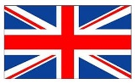 | - 15 April 1912, RMS Titanic sinks in the North Atlantic after hitting an iceberg, with the loss of 1,503 lives.
 | - 6 March 1987, MS Herald of Free Enterprise ferry capsizes near the Belgian port of Zeebrugge killing 193 passengers and crew.
 | - 20 December 1987, MV Doña Paz collides with a tanker while heading for Manilla, Philippines, and sinks, resulting in 4,386 deaths.
 | - 29 April 1994, MV Mtongwe ferry bound for Mombasa capsizes 40 meters from port and 272 of the c400 passengers die.
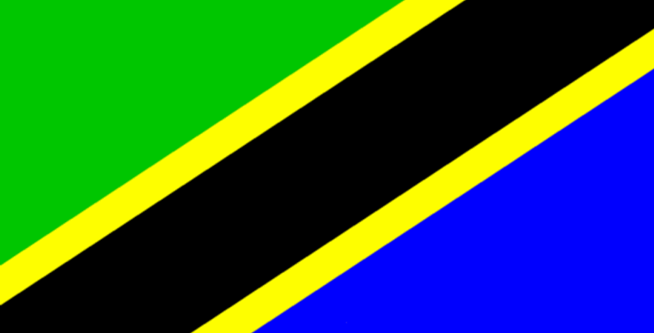 | - 21 May 1996, MV Bukoba capsizes 56 km from Mwanza on Lake Victoria and between 800 and 1,000 people perish.
 | - 10 September 2011, MV Spice Islander I sinks off the coast of Zanzibar with the loss of 1,573 lives.
 | - 16 April 2014, South Korea’s MV Sewol sinks with 476 passengers on board with the loss of 304 lives, mostly students.
 | - 20 September 2018, MV Nyerere capsizes in Lake Victoria with the loss of 228 lives.

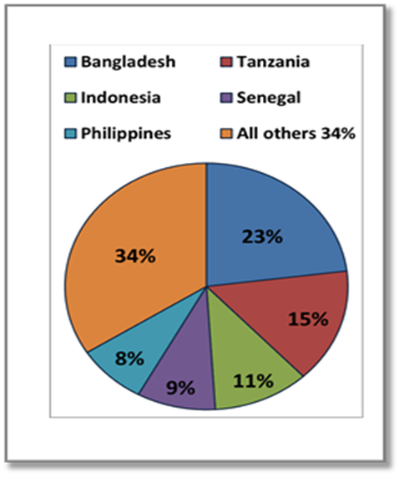
According to a 2016 study by the Worldwide Ferry Service Association, Bangladesh, Tanzania, Indonesia, Senegal, and the Philippines accounted for almost two-thirds of all ferry fatalities in the period 2000-14, with Tanzania the second largest (see sidebar). Bangladesh, Indonesia and Philippines have much larger ferry fleets and numbers of passengers than Tanzania, making Tanzanian ferries far more dangerous in comparison. If the indicator used was the number of fatalities in proportion to the number of passenger miles, Tanzania would leave these three Asian giants far behind!

The Kenyan and Tanzanian tragedies listed above were the result of reckless overloading. For example, the MV Bukoba’s manifest showed 443 first and second class passengers but there was no manifest for third class passengers. At least 800 people died. When the MV Spice Islander I sank in September 2011, its official capacity was 45 crew and 645 passengers, but it was carrying (by one estimate), well over 3,000 passengers. The Zanzibar minister of state, Mohamed Aboud Mohamed said: "The government will take stern measures against those found responsible for this tragedy, in accordance with the country's laws and regulations." Eight months later, the MV Skagit, another ferry on the same route, also sank, also with large loss of life.

In the case of the MV Nyerere, the manifest did not survive the tragedy, but we can estimate that, if the ferry was built to carry 100 passengers, 228 died and 40 were rescued, then 168 additional passengers were on board. Finally, with room for three small motor vehicles, the ship was also carrying a truck loaded with cement. Who should we blame?

Blame the victim. Commenting on the disaster, the Swedish Safe Waters Foundation lamented the ‘lack of learning’ from the MV Bukoba disaster over two decades ago:
‘We have seen several workshops … with … the International Maritime Organisation (IMO). We have seen a handful of consultancies twisting and turning the safety structures – or rather the lack thereof. We have seen dozens of patrol/rescue boats donated to the governing bodies of the lake, and we have had a joint … set of regulations governing the lake for over 10 years – the 2007 Lake Victoria Transport Act, clearly stipulating how to act on the lake. Last but not least, we have had NGO´s, among others Safe Waters/National Lake Rescue Institute, struggling to get accepted and allowed to contribute.
The author recommends five ways to improve the enforcement of safety and emergency search and rescue regulations, but doesn’t ask why boats are overloaded in the first place. Other commentators blame passengers for their fatalism: accidents will happen! Writing in the Saturday Nation on 29th September, Professor Austin Bukenya recommended ‘discipline’ among passengers, who should know better than to clamber onto overcrowded ferries. They should even consider buying their own life jackets! In a long article in the Daily News two weeks after the disaster, former speaker of the Tanzanian parliament Pius Msekwa, who hails from Ukerewe, praised the residents of Ukara for rushing to the scene of the accident and saving 40 people with their small boats, praised President Magufuli for swinging ‘immediately into unprecedented ‘rapid action’’, praised the Minister for Works, the Prime Minister, and the ‘Government team’, as well as TBC (the government’s TV channel) for keeping us ‘constantly informed of the rescue proceedings, and so on.’ Mr Msekwa found it ‘stranger than fiction’ that some Opposition politicians have taken delight in ‘pointing fingers’ at the Government for what they claim to be its delay in responding to this tragic incident.’ Finally, the former speaker, echoing the Prime Minister thanked God that ‘the situation is progressively returning to normalcy, because, despite the tragedy, normal life must go on.’ Not a word on the cause of the ‘tragedy’ or who should be held to account. Instead, ‘we should … applaud, the work which was so efficiently carried out by the Government team of Ministers and the commanders of the … security forces’ for completing their difficult tasks ‘in only eight days.’ An editorial in Tanzania’s government-owned Sunday News (30 September) went one better by blaming the victims:
‘It is high time everyone realise that we all have a role to play in curbing accidents of that magnitude. One of the causes of the MV Nyerere capsizing is said to be overloading and wananchi are equally to blame as they continued entering an already overloaded ferry.
Sunday News, Dar es Salaam 30 September
‘It is high time everyone realise that we all have a role to play in curbing accidents of that magnitude. One of the causes of the MV Nyerere capsizing is said to be overloading and wananchi are equally to blame as they continued entering an already overloaded ferry.’

Writer Nkwezi Mhango added to the ‘blame the victim’ narrative with the following admonition: ‘If you see that the … ferry is filled beyond its capacity, why do you embark ... knowing what can happen?’

In a more critical vein, one American commentator was blunt enough to blame “…human error. Criminal incompetence would be the best way of putting it.” But he stopped short of identifying the criminally incompetent. Another commentator grasped part of the bigger picture: “People make more money if they overload.” Out of many commentaries on the causes of the latest ferry disaster, the only one coming near the truth was Birungi Denis in a letter to the editor of the East African ( 29th September). The author identifies ‘monopoly’ as the cause of overloading, and the solution as ‘creating an environment for private players…’ But even this author refrained from taking his causal chain one step further, to ask what caused the monopoly. Why is the obvious cause of systematic overloading ignored by virtually all observers?

Why are boats so overloaded?
So why are Tanzanian and Kenyan ferries so overloaded? Clearly there’s a serious mismatch between supply and demand for passenger and cargo services if the ferries plying our seas and lakes can be so routinely overloaded. But why is there such a mismatch between supply and demand? Because our governments choose to run these services as state monopolies or semi-monopolies rather than encourage private companies to compete openly for the trade. What’s the explanation for this? After all, our governments no longer try to run inter-city buses or trucks. The monopoly of public transport services enjoyed by UDA (Usafiri Dar es Salaam) during the First Phase government was abolished under Phase II, leading to a rapid improvement in services with the arrival on the commuter scene of thousands of highly competitive, privately owned daladalas. A Lake Victoria ferry is a marine daladala. There is only one private ferry plying between Dar es Salaam and Zanzibar. Why are there not more? A previous attempt to bring a privately-owned ferry to Lake Victoria by road was frustrated by bureaucracy and politics. In October 2016, the MV Nyehunge II, a privately-owned ferry, was commissioned to provide passenger and cargo services between Mwanza and Ukerewe Island. MV Nyehunge I plies another route. The family-owned Songoro Marine Transport Ltd company builds commercial ferries in Mwanza. Kenya, theoretically a more ‘free-market ’oriented economy than Tanzania, maintains state monopoly control of its maritime transport through the Kenya Ferry Services, though privately owned craft ply Lake Victoria. Neither country is willing to loosen the tight grip of the state on ferry services on our lakes and the Indian Ocean. Virtual state monopolies cause Kenyan and Tanzanian catastrophes by providing inadequate services that inevitably lead to overcrowding. Licencing private ferries to serve single routes where there is no competition is far from liberalising Lake Victoria transportation, though it is a small step in the right direction. Will the 200-passenger capacity ferry ordered by President Magufuli solve the transport problem for Ukerewe and Ikara islanders? Or will it merely allow a doubling of the overload factor? Given the opportunity, private investors would scramble to provide these basic transport services. Why put additional pressure on the country’s transport budget, already seriously overstretched with major air and rail projects, when private capital can fill the gap?
So who do we hold responsible?
Most commentaries miss the point when attributing blame for such disasters as those listed above. Rather than focus on the culpability of the officials routinely endangering lives by overloading vessels, they lament the lack of lifeboats or life-jackets, untrained navigators, inadequate maintenance and so on. An editorial in the East African mentioned the lack of search and rescue services and a ‘robust system’ to control overloading. The obvious starting point—that government agencies perform virtually all the roles that affect the safety of passengers, and therefore share full responsibility for disasters when they happen—is carefully avoided.

To reduce the likelihood of such tragedies recurring, and in the interest of natural justice, it is essential that those responsible be held to account. So who should we hold responsible? In the Kenyan and Tanzanian cases, government agencies perform ownership, management and regulatory functions. We may rule out the Lake Victoria Basin Authority, an agency under the East African Community, as a key actor, although it has a notional mandate on lake transport security issues. To date, none of the tragedies listed above has led to prosecutions or punishment of those responsible. Given President Magufuli’s ongoing crusade against corruption and waste in government, we can hope that this time will be different. But as justice has never been done in the past, why should we expect things to be different now? If no sanctions are brought against those responsible for these major disasters, there is no reason for them to clean up their act. Very few senior officials are ever jailed for such crimes in Tanzania or Kenya.

If MV Nyerere had been privately-owned and run, you can be sure that Prime Minister Majaliwa would not be talking about life quickly ‘getting back to normal’ on Ukara island: more likely he and President Magufuli would be ‘demanding justice’, and arrests, not just sackings, would have already taken place. To make this point clear, here’s how Koreans dealt with their 2014 tragedy listed above, when over 300 passengers, mostly high school students, died on their way to a holiday island.
The Korean way with a major ferry disaster
On 16 April 2014, the privately owned and managed MV Sewol sank with the loss of 304 passengers and crew. The sinking resulted in widespread social and political outrage within South Korea, directed at the government of President Park. In class actions, bereaved families sued the government and ferry owners. The ferry was apparently carrying more than double the ship's passenger limit. In November 2014, the captain of MV Sewol was sentenced to 36 years in prison while the eleven other crew members were indicted for abandoning ship. The company's CEO was charged with ‘causing death by negligence’. The owner of the ferry later committed suicide. In July 2018, a Seoul court ordered that every family receive USD175,000 for each victim, and additional compensation of up to USD70,000 for each family member. The bereaved continue to sue the owners of the ferry.

What does this sad story teach us? First, that private ferry owner-operators are also capable of bending the safety rules and overloading their vessels for profit, with fatal results. But second, public outrage is not only permitted but is directed at the government as much as the boat-owner, for failure to enforce safety regulations or rescue more passengers. (Three years later mass demonstrations over grand corruption scandals led to the ouster of President Park, who is now in jail). Lesson: those responsible for the disaster were quickly identified, prosecuted and punished. Why should the bereaved in the MV Nyerere case not protest against the government officials responsible, as surely they are, for the deaths of their loved ones? Clearly the Koreans have something we are lacking: accountability.
The Nile perch in the room
If the majority of the passengers on board the MV Nyerere were not listed on the ship’s manifest, it is highly likely that the fares they paid for their final voyage also went unrecorded. A simple task for the official commission of enquiry will be to examine past manifests and accounts of the MV Nyerere to establish what proportion of income was reported officially and how much was turned into rents. This question was not asked when the MV Bukoba sank more than 22 years ago, but at the time it was widely believed that unrecorded passengers and freight generated considerable rents that fed a food-chain stretching from Mwanza to Dar es Salaam. Government officials and informed Tanzanians know how this system works. Rent-seeking alone explains official reluctance to privatise lake transport services in the interest of ordinary citizens’ safety and livelihoods.

MV Nyerere is named after the father of the nation
In sum, running commercial ferries on Lake Victoria or anywhere else should not be a state monopoly. Neither should it be a private monopoly or cartel, but a lively competitive market with multiple players and properly enforced regulations that balance the legitimate search for profit with the fundamental imperative of assuring passengers’ safety. Unfortunately, the relationship between state and private sector in Tanzania and Kenya rarely allows for transparent economic policy and regulation that is not motivated by collusive deal-making involving elements of both bribery and extortion. Lakeside people will continue to risk their lives on a daily basis until this fundamental constraint is addressed.

The MV Nyerere is named after the father of the nation. When he was in power, the policy of state control and management of many important commercial activities, including transport, ensured that parastatal ferries continued to ply Lake Victoria, as they had under colonial rule. No subsequent government has seen any reason to change this. Indeed, a new parastatal ferry company, the Marine Services Company, was set up the year after the MV Bukoba tragedy! At the end of his presidency, Nyerere was eventually obliged to step aside and watch as capitalism was allowed back in. But the widespread official mistrust of private enterprise that he shared with many at the time continues to this day, as does state management of ferry services. Until the Tanzanian and Kenyan states accept that private companies can provide cheaper, more efficient and safer maritime transport services, we should expect overcrowded ferries to continue to capsize on Lake Victoria and in coastal waters causing many deaths, ‘collateral damage’ if you like. Few observers are prepared to dig deep into ferry operations for fear of coming across smelly Nile perch in the process. To summarise the argument:

- The consensus is that the MV Nyerere capsized as a result of overloading;
- Overloading is the result of human error: those consciously and purposely overloading the ferry were responsible for its capsizing and the consequent deaths;
- Since the ferry is state owned and managed, and maintenance and enforcing safety controls are state responsibilities, those who should be held responsible for the tragedy are exclusively government officials, starting with the captain and crew;
- This mechanism creates considerable rents that are shared along the bureaucratic and political chain of command;
- The only workable solution to the problem of overloading is the liberalisation of the industry to attract foreign and local investment in a competitive market to replace a state monopoly;
- Accidents will continue to happen whoever runs ferry services; however, customers and safety lobbies will have greater say in the reduction of risk with private ferries, whose owners have practical incentives to avoid disasters.

The chart below summarises the causal chain.

CAUSAL CHAIN: WHY DID THE MV NYERERE CAPSIZE WITH THE LOSS OF 228 LIVES?

If one continued to analyse the causal chain, the next step would be to examine the incentives and motivations of actors in the state system, and the way in which the state relates to civil society, in the widest sense, and to business lobbies. This is too wide a topic to be addressed here.

ENDNOTES Brian Cooksey is an independent researcher and consultant based in Tanzania. A shorter version of this paper was published in October 2018 as: ‘That sinking feeling: Who is to blame for the MV Nyerere ferry disaster?’ The Elephant, Nairobi: https://www.theelephant.info/features/2018/10/04/that-sinking-feeling-who-is-to-blame-for-the-mv-nyerere-ferry-disaster/.
Survivors claim the pilot was talking on his mobile phone as he steered the ferry towards the jetty, and changed course abruptly when he realised he was approaching from the wrong side. See: Reporter 2018. ‘Tanzania ferry accident: Survivors recount what happened minutes before disaster’, 22 September: https://www.nation.co.ke/news/Tanzania-ferry-accident--Survivors-recount-what-happened-/1056-4772628-5x6jirz/index.html.
‘Management of capsized ferry on Lake Victoria arrested after order from Tanzania president’, South China Morning Post, 22 September.
TEMESA is a relatively recent agency (est. 2005) whose ‘mission’ includes ‘running safe and reliable ferry services…’ See: www.temesa.go.tz/.
Did the President sack the right people? In November 2017, President Magufuli signed the Tanzania Shipping Agencies Act 2017 which established the Tanzania Shipping Agencies Corporation (TSAC), which took over SUMATRA’s responsibilities concerning marine transport regulation. TSAC was supposed to become operational in February 2018. See: Peter Kasanda, Esther Ernest and Daniel Green 2017. ‘Establishment of the Tanzania Shipping Agencies Corporation’, Klyde and Co., Insight & Knowledge: https://www.clydeco.com/insight/article/establishment-of-the-tanzania-shipping-agencies-corporation. The above source commented: ‘As TASAC will have a narrower scope, as compared to SUMATRA, it is hoped from a public policy perspective that the agency will operate with great efficiency and bring increased transparency to the Mainland Tanzanian Marine Transport sector. Furthermore, TASAC's board will be comprised of individuals from the private sector as well as from within government. This should allow the agency to operate with an effective commercial approach.’ It seems this has not happened.
See: https://www.youtube.com/watch?v=uR6CZUBEf84. Another parastatal company Marine Services Company Limited, founded in 1997, is based in Mwanza. It operates services on Lake Victoria, Lake Tanganyika and Lake Nyasa. https://en.wikipedia.org/wiki/Marine_Services_Company_Limited.
Maureen Odunga 2018. ‘MN Nyerere retrieval ends’, Daily News on Saturday, 29 September.
Syriacus Buguzi 2018. ‘Acacia commends front-liners in Mv Nyerere rescue mission’, Citizen, 1 October. See: www.thecitizen.co.tz/data/2595284-2866900-tm26i3/index.html.
Louis Kolumbia 2018. ’Former Tanzania CDF Waitara to lead team to probe MV Nyerere disaster’, September 24.
A figure of 5,000 deaths a year on Lake Victoria has been cited in a number of articles. It seems this figure dates from an article written in 2004 and cited in a legal dissertation. See Nakyoni Aisha: 2011. ‘Maritime safety on Lake Victoria: Analysis of the legal and regulatory framework’, Master’s Dissertation, Faculty of Law, University of Oslo, citing Alan Boyle 2004.’“EU Unilateralism and the Law of the Sea,’ Marius No. 330, Marius, Scandinavian Institute of Maritime Law, Oslo.
Abigail S. Golden and Roberta E. Weisbrod 2016. ‘Trends, Causal Analysis, and Recommendations from 14 Years of Ferry Accidents’, Worldwide Ferry Safety Association, Journal of Public Transportation, Vol. 19, No. 1.
https://en.wikipedia.org/wiki/Sinking_of_the_MV_Spice_Islander_I.
Casualties were at least 150. The ship was certified for a maximum capacity of 250 yet officials said it had 290 aboard at the time. See: https://en.wikipedia.org/wiki/MV_Skagit.
https://forsafewaters.wordpress.com/author/safewatersfoundation/
Austin Bukenya 2018. ‘’The vessel tipped over’: The long, sad saga of helpless water people of E. Africa’, Saturday Nation, 29 September.
Pius Msekwa 2018. ‘A terrible tragedy: Remembering the day when the M.V. Nyerere capsized’, Daily News, 4 October.
Editorial 2018. ‘Let’s draw lessons from MV Nyerere accident’, Sunday News, 30 September, emphasis added. To be fair, the editorial continues: ‘Passengers should not continue suffering in silence simply because they want to get home early or they can’t challenge operators of the mode of transport they will be using.’ (Emphasis added).
Nkwazi Mhango 2018. ‘MV Nyerere and our refusal to learn from our miseries’, Citizen, 10 October. He concluded by applauding ‘the current government for initiating … efforts to build … a new ship … after two consecutive governments sat on the matter…’
Krista Mahr 2018. ‘What capsizing of ferry shows’, Citizen on Sunday, 30 September, citing Neil Baird.Baird, a retired maritime published, went on to argue that International Maritime Organisation (IMO) safety standards are ignored in many countries because of “corruption and political interference.”
Krista Mahr op. cit., quoting Roberta Weisbrod of the Ferry Safety Group.
Birungi Denis 2018. ‘Ferry disaster a wake-up call to rethink safety of region’s transport systems’, letter to the editor, East African, 29 September. The author recommends PPPs.
A point made by Prof Zulfiqarali Premji 2018. ‘Involve the private sector in plans to avert tragedies’, Citizen, 4 October.
As Minister of Works, in 2014 the present president ordered TEMESA to lease a 300 passenger ferry to ply between Bagamoyo and Dar es Salaam to ease traffic congestion. The ferry was leased from a Danish firm for an 8-month period at a cost of USD5m. It was found to be too slow and never functioned commercially. Two feasibility studies by the World Bank that found the project economically unviable were ignored. A subsequent CAG audit was critical of the procurement process, and opposition MPs demanded that those responsible for the deal be brought to book. See: Reporter 2016. ‘ CAG reveals rot in Dar ferry purchase’, Citizen, 27 April, http://www.thecitizen.co.tz/News/CAG-reveals-rot-in-Dar-ferry-purchase/1840340-3178426-2mb8rgz/index.html.
Editorial: ‘That sinking feeling: More dead in Victoria’, East African, September 22-28.
The Lake Victoria Basin Commission (LVBC) is mandated to coordinate sustainable development and management of the Lake Victoria Basin in the EAC Partner States. The Lake Victoria Transport Act (2007) provides for the Commission ‘to regulate maritime safety and security, to make provision for the construction, survey, registration and licencing of all vessels used on the Lake, for the safety of passengers and cargo, for the competency of masters and crew and for other related matters.’ It performs none of these functions. A World Bank environmental protection programme implemented in part by the LVBC produced mediocre results (Ernst Lutz 2018. ‘How the Lake Victoria project came to be dead in the water’, Citizen, 29 September. The World Bank is also implementing a multi-country Lake Victoria Transport Programme with USD200m for the Tanzanian component, which is aimed largely at upgrading the main ports and surrounding infrastructure. The Project Information Document (Phase 3) states that the ‘demand for lake transport has declined over the last 20 years due to unreliable or broken rail connections to the maritime ports, unreliable ferry operations across the lake; and safety concerns following a number of accidents…’ (April 20, 2017: 3). See: http://documents.worldbank.org/curated/en/657341516278537911/pdf/ITM00184-P160955-01-18-2018-1516278535389.pdf . Neither the LVBC nor the World Bank address the issues raised in this paper.

